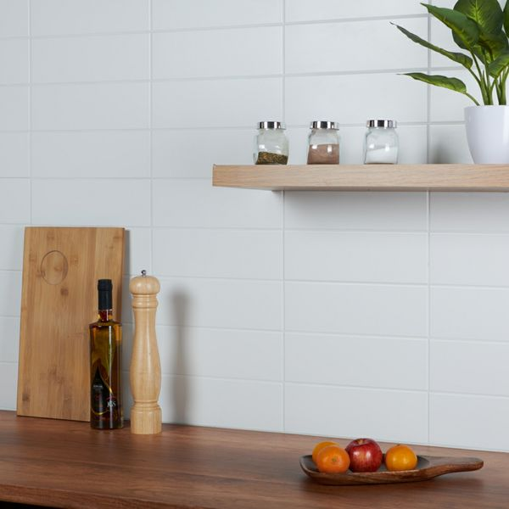

Linear White Matt Brick Tiles: <https://www.wallsandfloors.co.uk/linear-tiles-white-matt-linear-tiles>

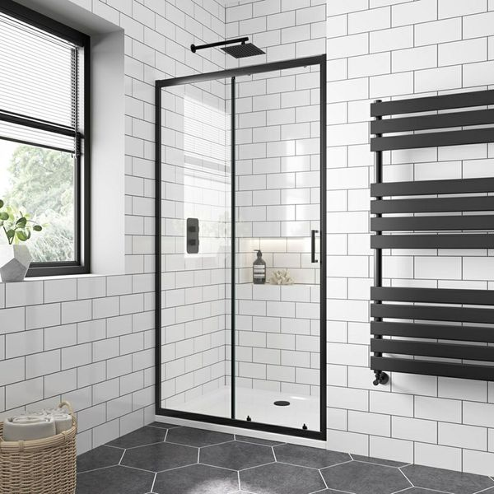

Flat Chalk Farm White Matt Tiles: <https://www.wallsandfloors.co.uk/flat-chalk-farm-white-matt-200x100-tiles>

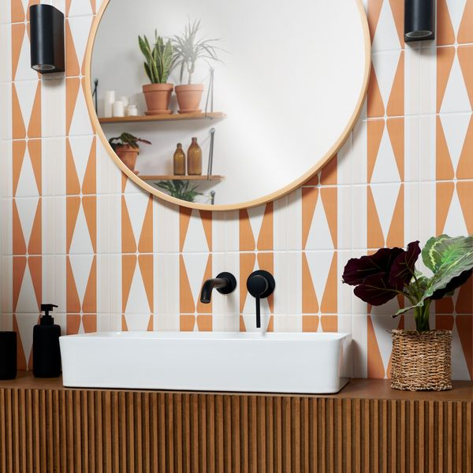

Marmalade Rene Pick n’ Mix Gloss Tiles: <https://www.wallsandfloors.co.uk/marmalade-rene-pick-n-mix-gloss-tiles>

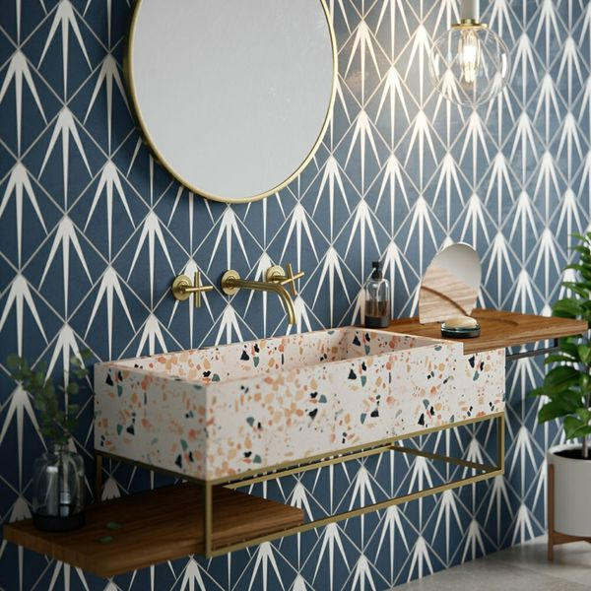

Gatsby Marine Tiles: <https://www.wallsandfloors.co.uk/linear-tiles-white-matt-linear-tiles>

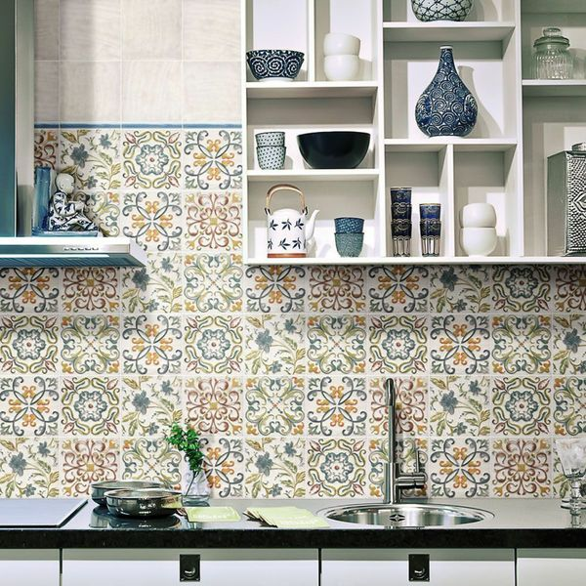

Lucy Floweret Decor Tile: <https://www.wallsandfloors.co.uk/lucy-tiles-lucy-floweret-decor-tile>